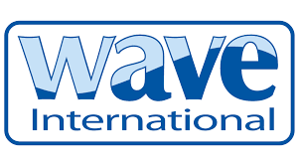

Wavestream’s inline bilge filters meet
new RCD requirements

Boat manufacturers have been given clearer guidance that watercraft are to be constructed so as to prevent the accidental discharge of pollutants. The recently updated Endorsed Recommendation for Use (ERFU#94) regarding the use of inline bilge filters relates to the Recreational Craft Directive (RCD/EU) and Recreational Craft Regulations (RCR/UK).

The RCD/RCR is the essential requirement designed to ensure that watercraft are constructed to ensure prevention of accidental discharge of pollutants such as oil and fuel overboard. It states the “fitting of a filter in the bilge pump discharge line with an oil output of no more than 15ppm which is interchangeable with a 5ppm filter in case of inland waterway use.” The new ISO 15083:2020 in part states this requirement endorsed by the ERFU.
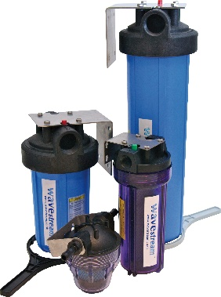
Wave International’s Wavestream bilge filters have been manufactured in the UK for over 20 years, and not only meet the latest RCD/RCR requirements, but also adhere to Lloyds Type Approval. Designed for the compact unit to be fitted inline with the bilge pump discharge line, the Wavestream’s cartridge filters work for both 15ppm and 5ppm, which means that boaters do not need to change their filters to meet the requirements of the new ISO and the RFU when going from coastal to inland waterways.
Paul Gullett, MD of Wave International welcomes the amendment to the ISO which clarifies the standards of inline bilge filters required. He says, “Boaters generally are very respective of the environment and do not want to cause any pollution but it’s hard to avoid, especially when refuelling or after carrying out any engine or maintenance work on board.” He explains: “Even a tiny trace of diesel or oil causes low level of surface pollution such as ‘blueshine’ which is when oil or diesel can be seen on the water surface.”
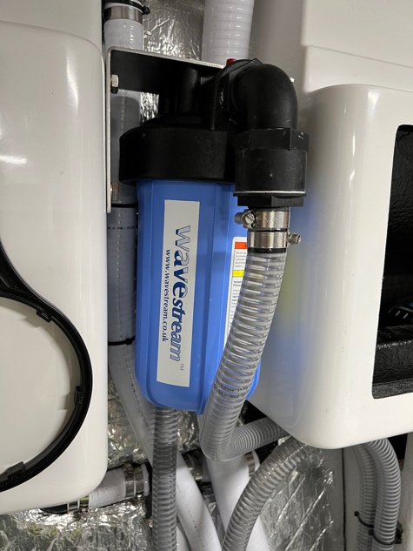
Welcoming the requirement for bilge filters used for inland waterways, Sites of Special Scientific Interest (SSSIs) and other key marine areas, such as National Marine Parks to be at the lowest level of 5ppm, Gullett says, “This revised ISO is a significant step forward in terms of environmental protection, Wavestream also removes very tiny plastic and waste particles, which could be ingested by fish and other wildlife.”
Wave’s systems comprise replaceable filter cartridges in a range of housings depending on the type and size of craft. They are fitted as standard by many manufacturers including Sunseeker, Oyster Yachts and Mangusta. The filters are designed to last for at least a season, depending on use, and are easily replaced. Many boaters carry spare filters with them, used filters can be responsibly and safely disposed of at marinas and boat yards.

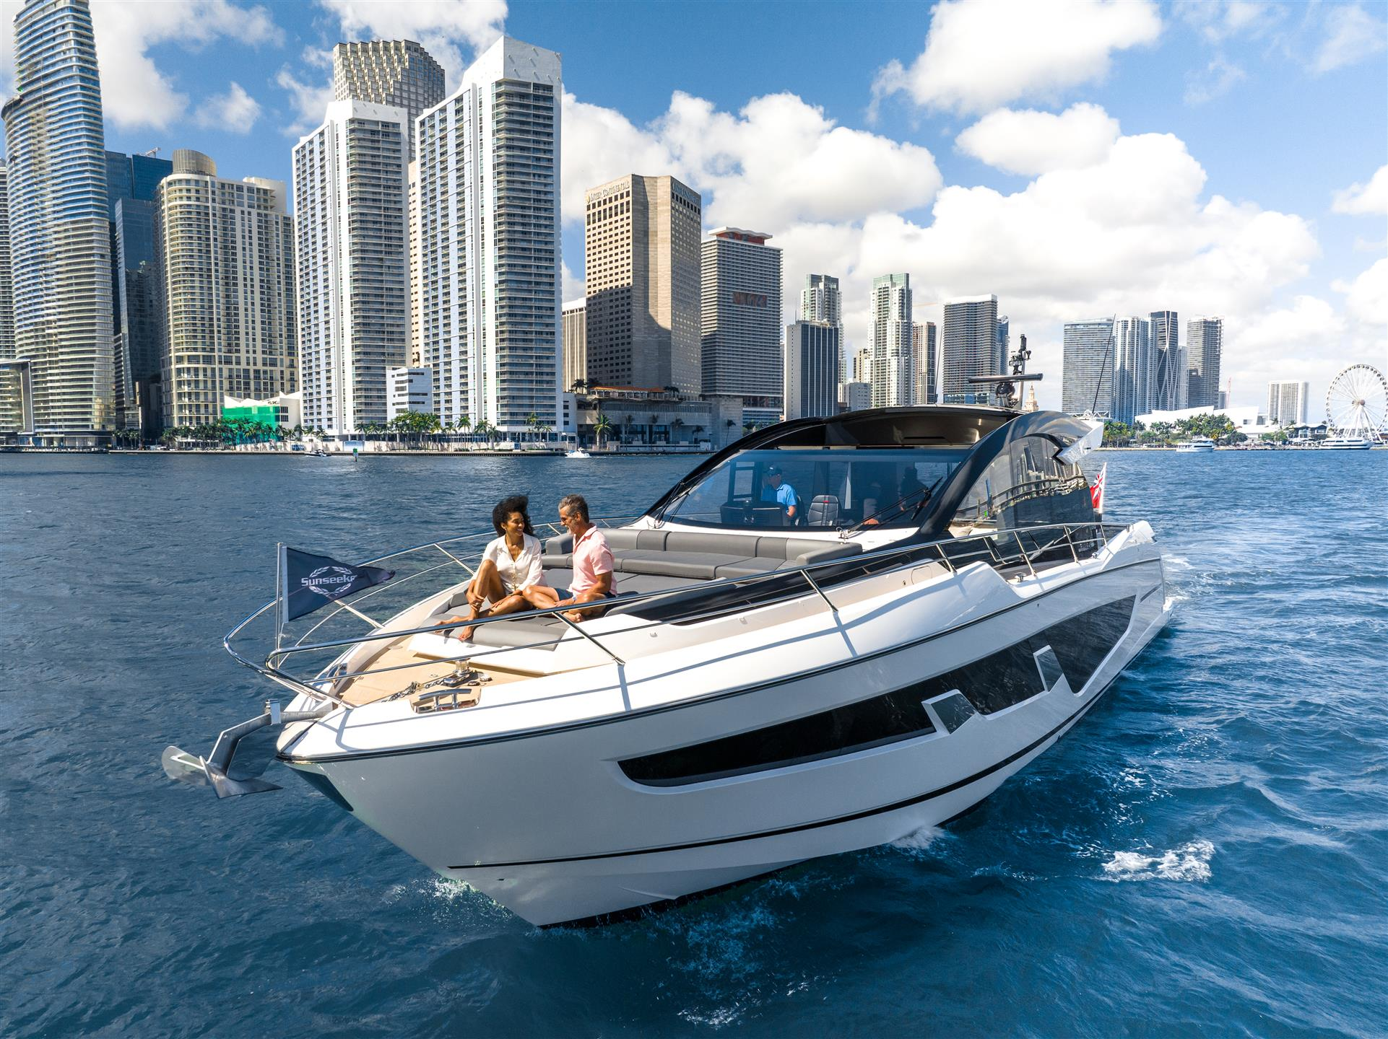

Photo showing Wavestream fitted into Predator 65, courtesy of Sunseeker International.

More information about Wave International products, this press release and high res images can be found at www.waveinternational.co.uk For more information contact Alice Driscoll, Consulting Partners, Tel +44 (0) 7971 019377 or email alice@consultingpartners.co.uk or Paul Gullett, Wave International, info@waveinternational.co.uk

High Res images available here: https://www.waveinternational.co.uk/news.html

March 2023 PR169-03

